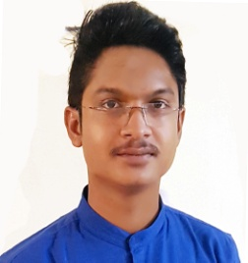 **BISWAJIT PRAMANIK**

C/O SUPRAVAT PRAMANIK

Mobile No. 09974192190

Krishnapu,Chaulkhola,

Email:[biswajit8973@gmail.com](mailto:biswajit8973@gmail.com)***/***biswajitpramanik8973@gmail.com

Ramnagar, Purba Medinipur,

West Bengal

Pin No.-721455

**Objective**

Seeking a deserving profile in the hospitality sector, where I can deliver my expertise and innovative hospitality skills, while maintaining the integrity and work ethics of the working environment, thereby maintaining the reputation of the organization. To work in a challenging atmosphere where my technical and communication skills as well as my sound servicing hand could be utilized allowing steady career growth.

**Work Experience**

* **(April, 14 – Jan,15 ) The Up Cycle Cafe, Bangalore.** Service cum Customer handling.

* **(Feb,15 – Sept,15)** **Sushruta Surgico Medical Products, Bhubaneswar.** Company dealing in ECG,TMT, PFT,,Monitor,Syring Pump, Ultrasound, Pulse Ox meters & its accessories and consumables etc.
* **(Nov,15 – Jul,16) Falafel Lover’s, Surat.** Accountant & Assistant Manager. (Handling customer enquiries and complaints, Greeting advising customers and taking reservations.)
* **(Aug,16 –** **Present) The Food Lab. Surat.** Restaurant Manager**.**

**(**Recruiting, training and supervising staff, handling customer enquiries ,complaints

Maintaining statistical and financial records.)

**Roles and responsibilities**

* Sales & Support in Private, Corporate, Semi Government & Government segment
* Support and development to existing customers
* Collecting technical and service support feedbacks directly from customers
* Customer relations development
* Installation & Providing service
* Follow up tender
* Overseeing stock levels
* Technical and application training to the End-user
* Dealing with contractors and suppliers

**Personal Skills**

* Comprehensive problem solving ability
* Ability to deal with people diplomatically
* Hard work
* Excellent customer service
* Communication

**Educational Qualifications**

* **BSc :** 2nd Year ( BSc not completed)
* **12th :** (2014) from Pichhabani Bani Niketan High School , W.B.C.H.S.E.
* **10th** **:** (2012) from Islampur High School, W.B.B.S.E.

**Computer Proficiency:**

Operating systems: Windows XP, Vista and Windows 7, Photo Shop, Microsoft Word & Excel.

**Personal Profile**

**NAME**  :BISWAJIT PRAMANIK

**FATHER’S NAME** :SUPRAVAT PRAMANIK

**PERMANENT ADDRESS**  :Vill. - Krishnapur

P.O.- Chaulkhola

P.S.- Ramnagar

Dist.- Purba Medinipur

**DATE OF BIRTH**  :23 rd July 1994.

**LANGUAGE KNOWN** :Bengali, Hindi, English, Oriya.

**NATIONALITY**  :Indian

**RELIGION**  :Hindu

**MARITAL STATUS**  :Unmarried

**HOBBIES** **:**Listening to Music, Watching

Movies, Cricket

**DECLARATION** : I hereby declare that all the statements furnished in this Bio-data are true.

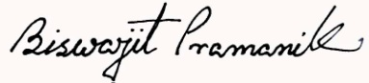**Date:** 01/07/2017

Place: Surat (Biswajit Pramanik)